IMAGE-BASED VISUAL HULL

Merit 2005 (Rite)

Mohammad Alhamarneh (UMCP)

Professor: Dr. Rama Chellappa

Gradate Assistant: Zhanfeng Yue

Monday 8-8-2005

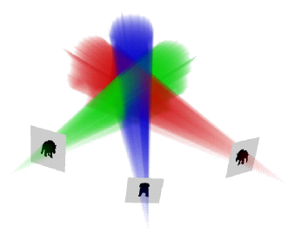

Table of Contents

I- Introduction

  - Visual Hull 3

  - Previous Work 4-5

II- IBVH Computations

2.1 IBVH Algorithm 5-6

2.2 Line/Silhouette Intersections 7-8

2.3 Visual Hull Shading 9

III- Modifying Existing Algorithm

3.1 Original Algorithm 10

3.2 Changes Made 10-11

IV- Results 12

V- Conclusion 12-13

Appendix A (Input & output images) 14

Appendix B (Epipolar geometry) 15

References 16

Abstract:

Visual Hull (VH) is an approximate 3D geometric representation of an object that contains the actual object. Image-based visual hull (IBVH) is generated using silhouettes information from multiple 2D reference images of the object. Taking advantage of epipolar geometry, 3D ray intersections required to construct the VH are reduced to 2D line intersections, which greatly simplify the computation. The VH is then used to generate images of the object from any desired viewpoint by placing a virtual camera at the point. I modified an existing algorithm that computes IBVH of an object of interest and produces images along a circular trajectory around the object, mainly on extracting the required camera parameters from the given camera calibration matrices. One important application of IBVH is generating pose-invariant view for recognition applications.

I-Introduction

1.1- Visual Hull

Visual Hull (VH) is an approximate 3D geometric representation of an object resulting from projecting and intersecting all silhouettes from multiple views, see figure 1 on the next page. VH has the property that it always contains the actual object, and it is an equal or tighter fit than the object’s convex hull. However, VH does not capture concavities in the original object, since concave surfaces cannot be recovered using silhouettes information only [3]. Given a set of reference views $R$of a 3D object and each reference view $r∈R$ has the silhouette, $Sr$which covers the object interior pixels. For each $r$, we create a cone- like shape $\text{vhr}$ which is defined by all the rays resulting from projecting each point inside the silhouette from the image’s center of projection and passing through these points on its image plane. The result is the volume $\text{Vh}R=∩r∈R\text{vh}r$, in which the actual object is contained [3]. There are many methods that compute and render the VH. Those methods are generally categorized into three main categories: geometric, volumetric, or image base rendering. In the following section, I discuss one method of each category.
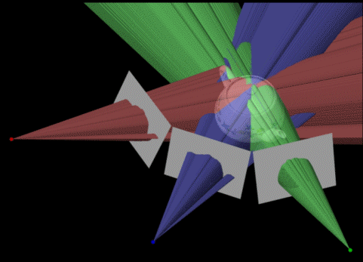

Figure 1: Visual Hull of a tea pot

1.2 - Previous Work
- Volume Carving: volume carving is a method that constructs the VH given the reference views silhouettes. For each reference view, the voxels that lie outside the projected silhouette cone are eliminated from a volumetric representation of the object. The process is repeated for all the reference views. The resulting final volume is a quantized representation of the object’s VH [3].
- Conservative Solid Geometry (CSG): CSG uses ray tracing to render an object defined by a tree of CSG operations. One considers each ray separately and computes the intervals of intersections between that ray and the object. This approach requires the computation of expensive 3D ray-solid intersections.
- Image Base Rendering (IBR): in IBR techniques, reference images are used to generate new ones. IBR techniques depend on re-projection of reference image pixels into desired image. IBR rendering methods has many advantages, they only need few reference images as an input, their speed is independent of the scene complexity, and they have a stunning realism [4].
This paper describes Image-Based Visual Hull (IBVH), which is an efficient geometrically valid pixel re-projection method to compute the VH. The algorithm was implemented and tested by Zhenfeng Yue at the Center for Automation Research in the University of Maryland. In addition to computing the object’s VH, the above algorithm also generates a turntable image collection (a set of virtual views that go around the object in circular trajectory). The reminder of this paper is organized as follows, section 2 describes IBVH computations, section 3 discusses the modification that I added to the algorithm, results are presented in section 4, and conclusion is in section 5.

II- IBVH Computations
2.1-IBVH Algorithm
The IBVH algorithms have two distinct characteristics: it is computed in the image space of the reference images, and it is view dependent. This helps eliminate the re-sampling and quantization artifacts, which are present in volumetric approaches such as volume carving. Computing the IBVH involves three steps:
- The ray for each pixel in the desired image is projected into a reference image.

- The intervals of intersections between the projected ray and the silhouette are computed.

- Those intervals are lifted back into 3D onto the desired ray where they are intersected with intervals from other reference images to give the VH.

Figure 2 on the next page shows this procedure.

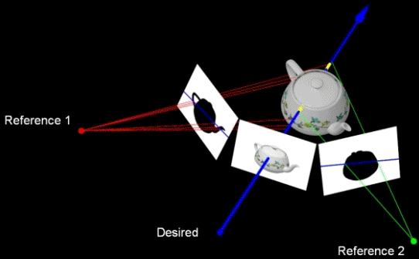
1
3

2

Figure 2: IBVH three steps calculations

If a pinhole camera model is used, the following equation gives the projected ray in 3D for a homogenous image coordinate $x$:$X(t)=C+\text{tPx}$ (1), where C is the camera’s center of projection and P is the camera projection matrix. The projection of a point A in 3D into the camera’s image plane is given by$a=P^{−1}(A−C)$ (2). Also, we can accomplish step 1 of the algorithm above by projecting two points of the ray into the reference image and then determining the line between them. Step 3 of the algorithm above can be established by determining the 3D location of the start/end points of the interval in 2D. This is just the intersection of two rays: the desired image ray and the reference image ray of both the start/end point of the interval. In the next section, I discuss how to compute the line/silhouette intersections in step 2 above efficiently by taking advantage of epipolar geometry.

2.2 -Line/Silhouette Intersections
For definitions and terminology of epipolar geometry, please see appendix B attached. As a scanline (group of adjacent pixels) in the desired view d is traversed, each pixel projects to an epipolar line segment in the reference view r. These epipolar lines intersect at $e\text{dr}$, the projection of d’s center of projection into r image plane, and they form a family of epipolar lines that have a slope m which is either increasing or decreasing monotonically depending on the direction of traversal. By taking advantage of this property, we compute the line/silhouette intersections for the whole scanline [3].
Figure 3 below shows this monotonicity property.
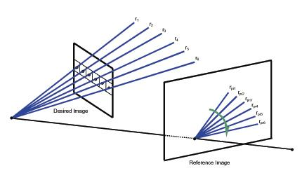

Figure 3: The Monotonically slope of epipolar lines

The algorithm for the line/silhouette intersection is summarized as follows:
- Represent the silhouette contour of each r as a series of edges.
- Order the vertices of the silhouette contour in increasing order using the slope m of the line that connects each vertex with the epipole $e\text{dr}$.
- The ordering of vertices in the previous step divides r into bins (regions between consecutive vertices). Each bin has a slope range m that spans $m\text{start}<m<m\text{end}$corresponding to the slopes of the lines that pass through the start and the end vertices of the bin. Each bin then is assigned a set of edges, which are intersected by epipolar lines that have slope which falls within the bin’s slope span. See figure 4 below.
- As the pixels of a scanline in d are traversed, the projected rays fall within the epipolar lines family in r with either increasing or decreasing order.
- Taking advantage of the monotonicity property, the bin for each projected epipolar line is searched for and located incrementally, and the epipolar line is intersected with the edges in that bin.

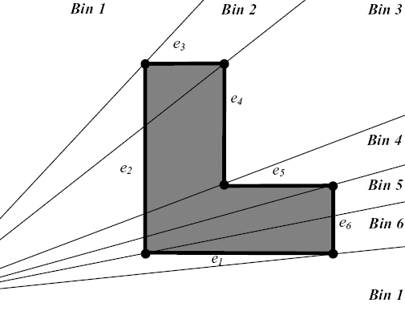
Figure 4: Partitioning of the silhouette contour to edges and bins.

2.3-Visual Hull Shading
Although the IBVH algorithm that I modified did not shade the resulting VH, I will summarize in this section the shading algorithm devolved in [3] for the sake of completeness. The shading algorithm in [3] uses view dependent texture mapping from reference images in order to capture as many view dependent effects as possible. The algorithm is outlined as follows:
- For each front most pixel in the VH, the reference images are ranked from best to worse according to the angle between two vectors. These two vectors are the ray from the sample VH point to $C\text{ref}$, the reference image center of projection, and the ray from the sample VH point to $C\text{des}$, the desired image center of projection. The reference image that has the smallest angle is the one selected.
- The visibility of the VH surface point as seen from the closest reference image is determined. This will ensure that points on the VH which are blocked off from the reference image by other parts of the VH or any other geometry will not be shaded using that reference image, regardless of how good that reference image aligns with the desired line of sight. Again, advantage is taking of epipolar geometry to reduce 3D visibility calculations to 2D using epipolar plane (see appendix B for definition of epipolar plane).
- The VH point is projected into the reference image, and it is shaded in an interpolation of colors from the closest four pixels in the reference image to the point of projection.

III- Modifying Existing Algorithm
3.1- Original Algorithm
The IBVH that I modified computes the VH of an object. It also generates a turntable image collection, which is a set of virtual views that go around the object in circular trajectory by moving a virtual camera around the computed VH. This method is combined with template matching to produce pose-invariant views for recognition applications [4].
The original sequence that the algorithm was implemented and tested on has the extrinsic required camera parameters explicitly available to use at each reference camera’s position used to compute the VH. Those extrinsic parameters are the angles $\left\{φ,θ,ψ\right\}$(pitch, yaw and roll, respectively) around the X, Y, and the Z-axis respectively, and the camera translation vector T={Tx, Ty, Tz}.

3.2- Changes Made
Every camera motion is a combination of translation and rotation. We need to know the exact location of the camera’s position in 3D space in order to compute its projection matrix P to be able to produce images. I modified the existing algorithm so that it works for a new sequence of silhouettes images which had a different camera calibration files. The new sequence has the 3D reference cameras centers of projection C={Cx, Cy, Cz} and the$\left\{φ,θ,ψ\right\}$angles. The projection matrix P for each of the reference cameras can be derived as follows:
- Given$\left\{φ,θ,ψ\right\}$angles, form the rotation matrix R. This is done with the standard technique of converting Euler angles around three perpendicular axes to a rotation matrix [2].
- Form the camera translation vector T = -RC (3).
- Form the camera projection matrix P= K [R T] (4) where K is the known camera intrinsic parameters matrix.
The modified algorithm successfully computed the VH of the new sequence frames; results are presented in the following section. Up to the time of writing this report, I’m still in the process of modifying the algorithm so that it will also work for generating the turntable image collection. Apparently, the camera calibration method used for the new sequence cameras is different than the one used for the old sequence ones. The orientation of the X, Y, and Z -axis is out of order in both sequences. In the original sequence, [4] assumes that the Y-axis is the one perpendicular to the ground plane and the virtual camera moves around it. In the new sequence the Z– axis is the one perpendicular to the ground plane, and so the algorithm has to change based on that.

IV-Results
The new modified algorithm was tested on the new sequence. It successfully computed the VH and generated views corresponding to the virtual camera viewpoint.
- Input: the silhouettes images and the cameras calibration information for six reference cameras.
- Output: the computed VH and the rendered virtual views seen from the viewpoint of the virtual camera.
Two examples of input and output images are shown in appendix A.

V-Conclusion
In conclusion, I presented the main concepts and techniques of IBVH. In the introduction part, we looked at the concept of VH and previous work. In section 2, the IBVH computation, intersection, and shading algorithm were discussed. Section 3 explained the modifications that were made to the IBVH algorithm implemented by [4] in order to make it functional for a sequence with different cameras calibration files. Results were presented in section 4.
Finally, some of the pros, cons, and application of this emerging technique are outlined below.
- Pros:
- Speed: the algorithm is one of the fastest of all current algorithms; taking advantage of epipolar geometry reduces involved 3D intersections to sets of 2D intersections.
- Quality/Robustness: good apparent output images, no suffering from quantization artifacts, and the algorithm works well with many different scenes regardless of their complexity.
- Low-cost: no expensive hardware devices required to implement the system.
- Cons:
- Not exact geometry: concavities in the object’s geometry are not captured.
- Expensive preprocessing: costly background subtraction is required to get the silhouettes images.
- Applications:
- Digitizing sporting events and viewing the scene from any desired viewpoint.
- Reducing the number of cameras used to fully capture the whole scene.

Appendix A

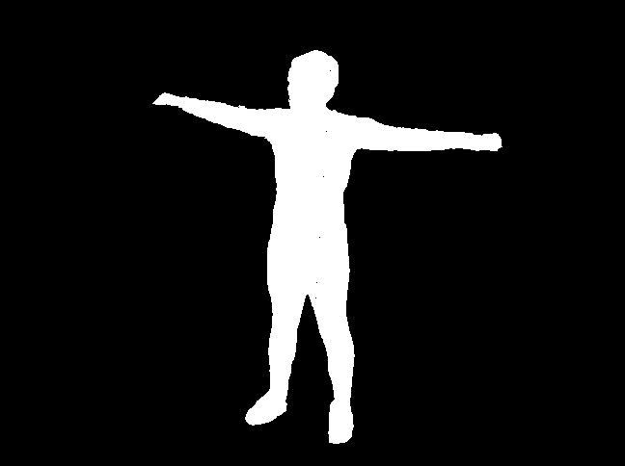

Figure A1: Input silhouettes images for frame 1
Ground Truth
Output

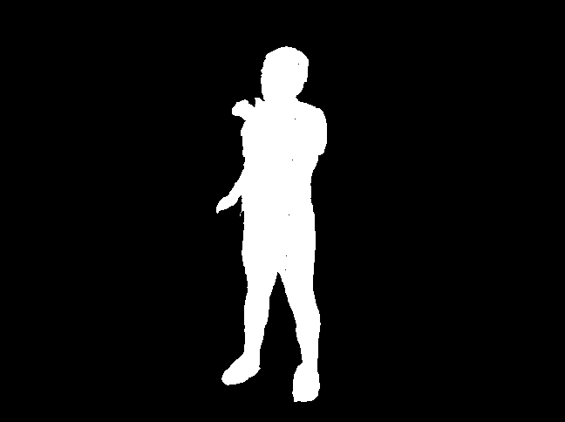

Figure A2: Input silhouettes images for frame 2
Ground Truth
Output
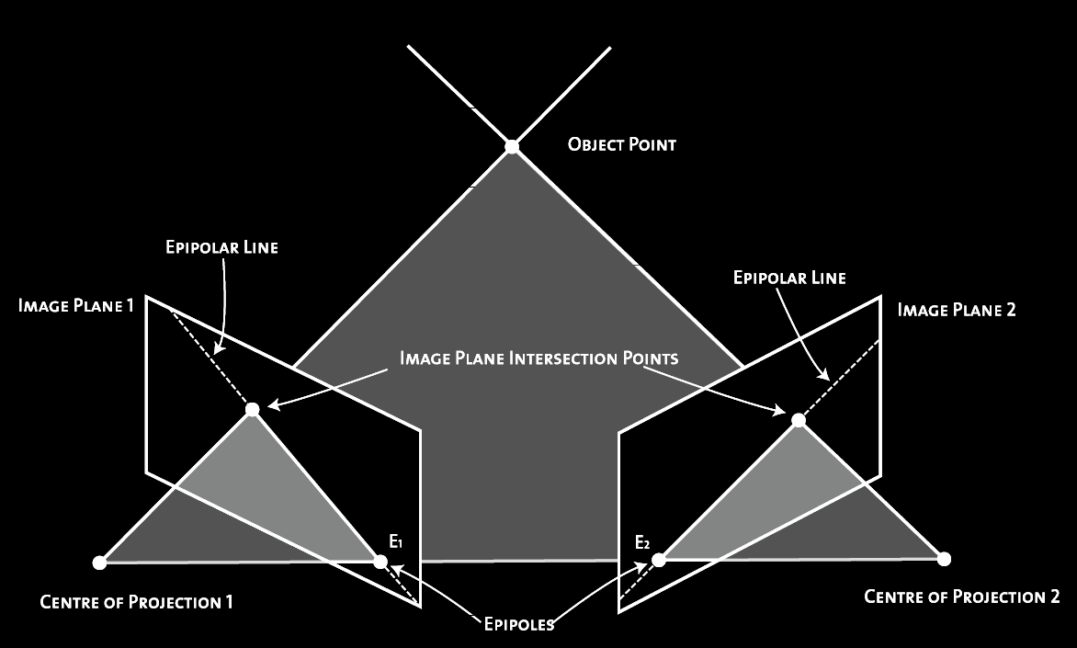
Appendix B

Epipolar Geometry: the geometry that relates two images to each other.
Epipolar Planes: the set of planes that share the line connecting the two images centers of projection.
Epipolar Line: the projection of an epipolar plane from one image onto the other.
Epipole: a common point where all the epipolar lines intersects, also it is the projection of one image center onto the other image view plane.

References
[1] Hartley, Richard and Andrew Zisserman. Multiple View Geometry in Computer
Vision. Cambridge: Cambridge University Press, 2000.
[2] Kwon, Young-Hoo. Computation of Orientation Angles. 1998. 19 Jul. 2005
< http://kwon3d.com/theory/euler/orient.html>
[3] W. Matusik, C. Buehler, R. Raskar, S. J. Gortler, and L. McMillan, “Image-Based
Visual Hulls,” Proc. SIGGRAPH 2000, pages 369-374,2000.
[4] Yue, Zhanfeng and Rama Chellappa, “Pose-Invariant View Synthesis Using Image-
Based Visual Hull”. Center for Automation Research, University of Maryland.

