Abstract 2
II. Materials and Preprocessing 4
III. Feature Detection 5
III.A The Topographical Primal Sketch 5
III.A.1 Principal Curvature 6
III.A.2 The TPS map 7
III.B Salient Points 9
III.B.1 Gabor Wavelets and Decomposition 9
III.B.2 Feature Detection and Salient Points 10
IV. Comparison Techniques. 12
IV.A. Correlation 12
IV.B. Hausdorff Metric 13
V. Combination Schemes 14
VI. Results 15
VII. Discussion 15
VIII. Conclusion 18
Works Citied 19

Abstract

The goal of face recognition research is to facilitate automatic identification or verification of people from their faces. Recent technological advancements have increased the feasibility of the use of 3D face models for this task. Three dimensional models handle variations in illumination and pose better than traditional 2D images. Comparison methods range from matching sparse point clouds to extracting dense features from the 3D surfaces. These involve calculation of principal curves, Gabor wavelet decomposition, matrix correlation, or the Hausdorff metric. These techniques were applied to range data of real faces and a combination of these techniques were evaluated.

This project was conducted under the supervision of Professor Rama Chellappa and Mr. Gaurav Aggarwal.
I. Background on Facial Recognition.

The purpose of automated facial recognition research is to create a system by which a computer can autonomously take a target face and either match it to one in a database of faces (verification) or confirm a match to a specific face (identification). Already, face recognition systems have already been implemented to a degree in real world situations. In Tampa Bay, for Super Bowl XXXV, the system “FaceIt” was used to monitor spectators as they entered the stadium. One advantage to such a system is that it is non-invasive. It does not require a person to produce an ID or in many cases to be isolated from the crowd to be examined. The number of faces a computer can “remember” accurately is also much more than the average human.
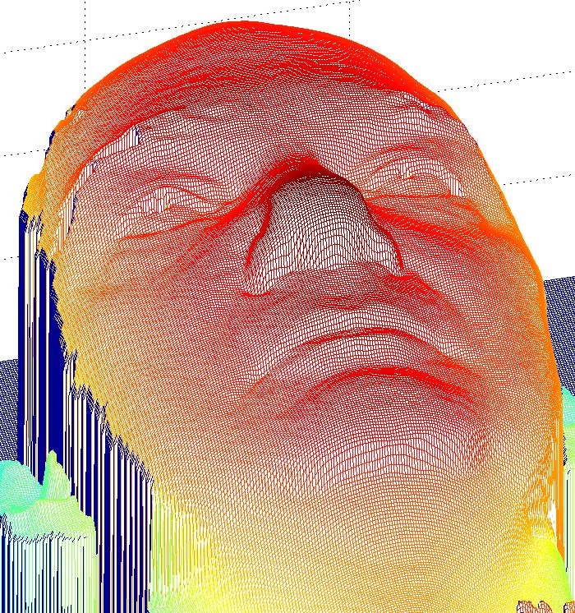
Traditionally, face recognition research has focused around analysis of a 2D image (from a digital camera or a still from am image sequence). But new, increasingly reliable technologies have turned more and more attention toward the use of 3D models. The primary advantages of three dimensional models are that they are invariant to illumination and pose. A change in light intensity or direction or in direction a subject is facing, in analysis, creates a face that is different from the original in 2D. Much of the techniques used in 2D analysis rely on “intensity images,” where the face is assumed to be a Lambertian surface, and features such as peaks, indentations, and concave and convex areas are determined by the intensity of the reflected incident light. Three dimensional models, however, record absolute position of a point on a face in the 3D realm. A point viewed from the side of the face in 3D is the same point viewed from the front. And because they are not dependant on light to illuminate all features at all times, 3D models give an accurate representation of a face surface.
Figure 1: A range image, a type of 3D model
Three dimensional face models can be captured or extracted by different systems[1]. The Minolta Vivid 900/910 system sweeps a gate pattern of light stripes across the face and measures the reflected intensity and creates a range image based on the measured values. Another system, the 3Q Qlonerator System, uses a bank of cameras on either side of a subject face and captures images from each view simultaneously. The system then combines the information from each image to create a 3D face model from stereo photography. Figure 1 shows an example of a captured 3D data, or a “range image.”
The process of facia recognition can be broken up into three areas: registration, feature detection, and comparison. Techniques for feature extraction and face comparison that were applied to 2D images can often be extended into the 3D realm. Sometimes techniques can be applied directly to the range image, where data is still dependent on a measure at an (x,y) coordinate, but the measure is a more accurate z coordinate instead of an albedos measure. Other techniques can modified take an actual three dimensional matrix, or point cloud, and perform calculations.
This project focused on the application of two feature detection techniques and two point set comparison techniques to a 3D face representation. Further, this project studied interaction between a combination of different feature detectors and comparison techniques. Features were modeled by a Topographical Primal Sketch or denoted as a salient point as discovered through Gabor wavelets. Faces were compared using the Hausdorff metric or through correlation of points.
The paper first talks about preprocessing of each face model through registration (which turns out to be important, as highlighted in the final sections). Then the techniques of TPS map creation and salient point discovery are explained. Next, the comparison methods of the Hausdorff metric and correlation are explained. Finally, the schemes of combined feature detection and comparison method are out lined and the results are presented. The end is a discussion of the results, highlighting an area of problem for the project and areas of further research.

II. Materials and Preprocessing

The data for this project was found on the Guanyin server in the UMAICS department. Face model data (stored as a gzip) consisted of a 6 lines. The first two lines where the dimensions of the image (640 x 480 pixels). The next three lines where long sequences of numbers denoting the x-, y-, and z-coordinates of each point on the face surface. The final line was a binary sequence of flags that described whether a point was a valid measured point or not, 1 equating to a “valid” value. All calculations and analysis of all aspects of this entire project were executed in MATLAB, versions 6.5.1 and 7.0, and performed on a Dell desktop with Xenon CPU (1.4 GHz) operating on Windows XP and on a Dell Latitude c610 with an Intel Pentium III mobile CPU (1.0 GHz) operating on Windows 2000.
The first step in many facial recognition systems is registration. This is to take the target face and transform it (azimuth, elevation, scale, and crop) so that it aligns with the stored gallery of faces. Automatic face detection (i.e. determining where a face is in a picture) and registration are another aspect of research in the entire facial recognition scheme.
In this project, a “weak” form of registration was developed. First, the program would read in and reshape the data from the .abs file. Then the program would attempt to crop the entire bust of the person down to a rectangle around the face. This was done to both focus only on the important aspects as well as bring down computation time. The process involved assuming the nose as the highest point on the face (this lead to problems, discussed later), then search outward from the nose for the edge at the top of the head and sides of the face and a gradient change above a certain threshold to denote the chin and jaw line. Finally, the program would center the tip of the nose to the center of the picture.
In MATLAB, this weak registration was performed in the created m-file, faceframe.m. Faceframe would take an input face and it’s flag matrix of valid points and return a new face that was cropped and centered around the highest point on the face, presumably the nose.

III. Feature Detection

III.A The Topographical Primal Sketch

Meth and Chellappa, in their 1999 paper, presented the Topographic Primal Sketch (or TPS) [2]. The TPS is a system to classify points based on responses to aspects of differential geometry. The signs and magnitudes of the principal curves and first directional derivatives can characterize a point on a face as one of a number of feature types.

III.A.1 Principal Curvature
A surface can be parameterized in the following in the i, j, and k directions:
Surface = xi + yj + zk
Given a smooth surface, a gradient can be defined based on the z-component, which translates into the 2-D range image of the model:
z(u,v) = f(x,y)
and the gradient is defined as:
del(z(u,v)) = dz(u,v)/du U + dz(u,v)/dv V

Where U and V denote the unit vectors in the directions of u and v, respectively. In an image, edges and peaks occur at zero crossings of the first directional derivative. Zero crossings occur at any place where the Laplacian of the function changes sign, or "crosses through zero."
The Hessian matrix is defined as:
H = [ ∂2z/∂i2 ∂2z/∂ij2 ]
[ ∂2z/∂ji2 ∂2z/∂j2 ]

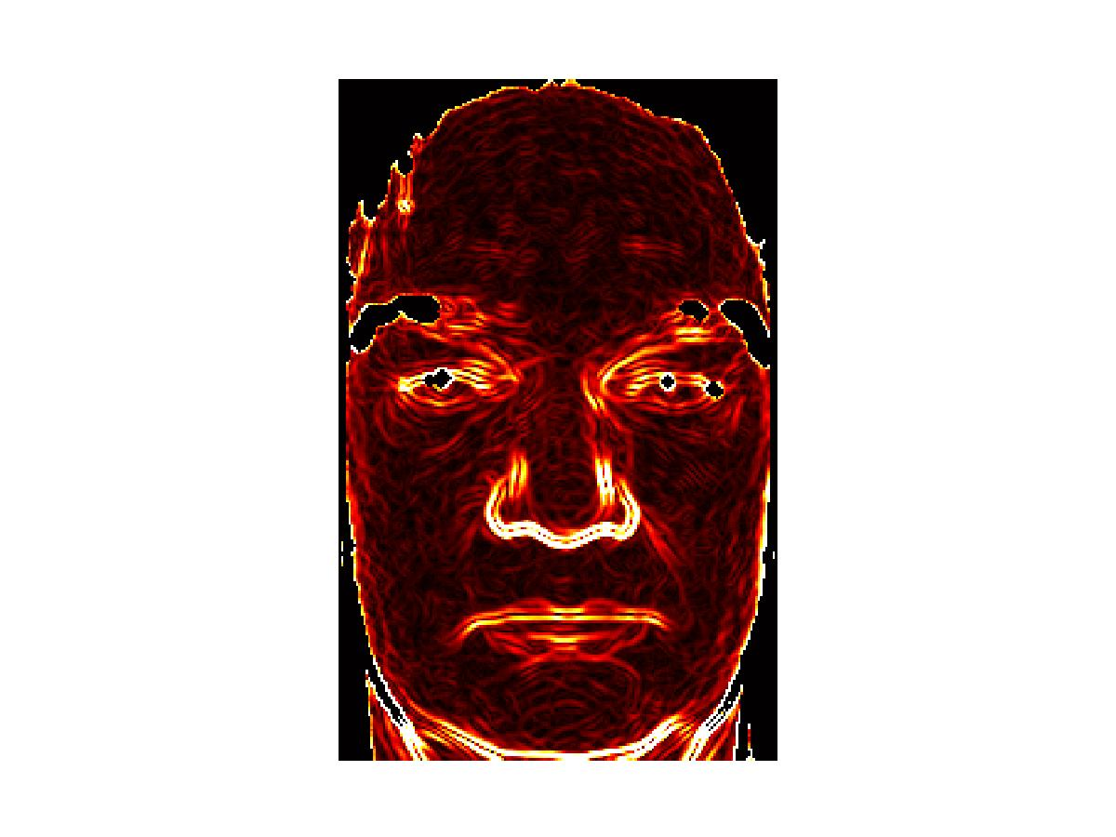
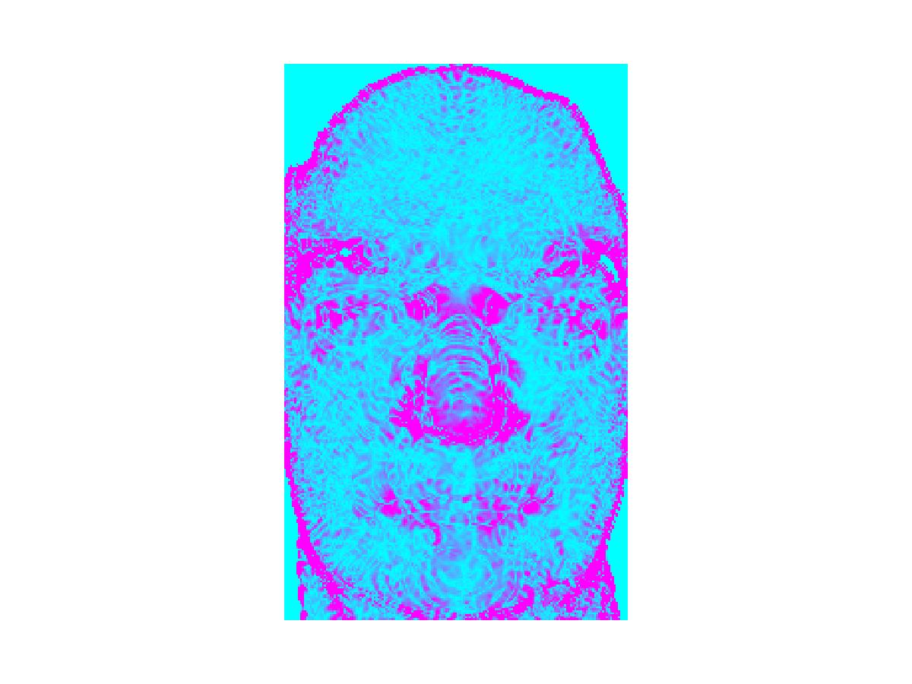
In other words, the Hessian is the Jacobian matrix of a function. This can be calculated as the del^2 operator, or the gradient of the gradient of the range image z(u,v). The eigenvectors are the 2nd derivative extrema of the function. The eigenvalues (λ _{1,} λ) and the associated vectors (ω ω) are also the principal curvatures and directions respectively. Figure 3 shows a magnitude image of the principal curvatures, the brighter the color, the greater the value. The principal curves of a point on a surface are where the surface bend the most and least. The curvatures (eigenvalues) are the magnitude of the curvatures and the vectors are the directions of the curve.
Figure3: Magnitudes of Curvature, max (right) and min(left)
With the gradient and 2D derivative extrema/principal directions known, the first and second derivatives of the function are calculated as:
z' = del (z •w_{n})
z'' = w_{n}^{t} H w_{n}
where [t] denotes the transpose. In MATLAB, gradients were found with the gradient command. Calculation of the principal curvatures and directions where executed with the created m-file, principal.m. Principal.m takes the range image and the flag matrix of valid face points and using the methods above, returns matrices of max and min curvatures magnitudes, k1 and k2, and matrices of max and min directions, <u1,v1> and <u2,v2>.

III.A.2 The TPS map
With this information, any pixel at a zero crossing can be categorized: peak, pit ridge, ravine, or saddle, breaking any face down into map in a consistent matter [2].
A peak occurs when the gradient is zero in all directions and the principal curvatures are both in the negative direction (i.e. curve downward). It is basically a local max of the surface in all directions.
A pit is the same as a peak except principal curvatures are both positive. It equates to a local minimum in all directions.
A ridge is a local maximum, but in one direction. The first directional derivatives area gain zero, and the sign of the maximum curvature is negative (downward curvature). But the magnitude of the minimum principal curvature is close to zero. On an ideal surface, the value would be exactly zero. However, for a digitized face, zero curvature may occur on the inter-pixel level. Also noise from the scanner or even numeric inaccuracy in the computer may introduce the slightest curvature that would, in the grander scale, be flat. These programs required thresholding to account for this in almost all calculations.
A ravine is like a ridge in shape. it is a local minimum, but in one direction. Again, there is a zero cross and a "zero" (small) magnitude or the minimum curvature, but the sign of the maximum curvature is positive.
Finally, a saddle point has a zero first directional derivative, but is neither a local max or min. Instead the curvatures have differing signs such that two parts of the local surface slope up and other parts slope downward.
Any points that do not take a zero crossing can be classified as a any type of flat, non-peaking surface: plain, slope, etc. Table 1 (below) presents a breakdown of the classifications [2]:
Table 1: Point Classification based on Directional Derivative and Principal Curvature Response
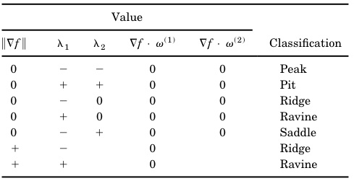
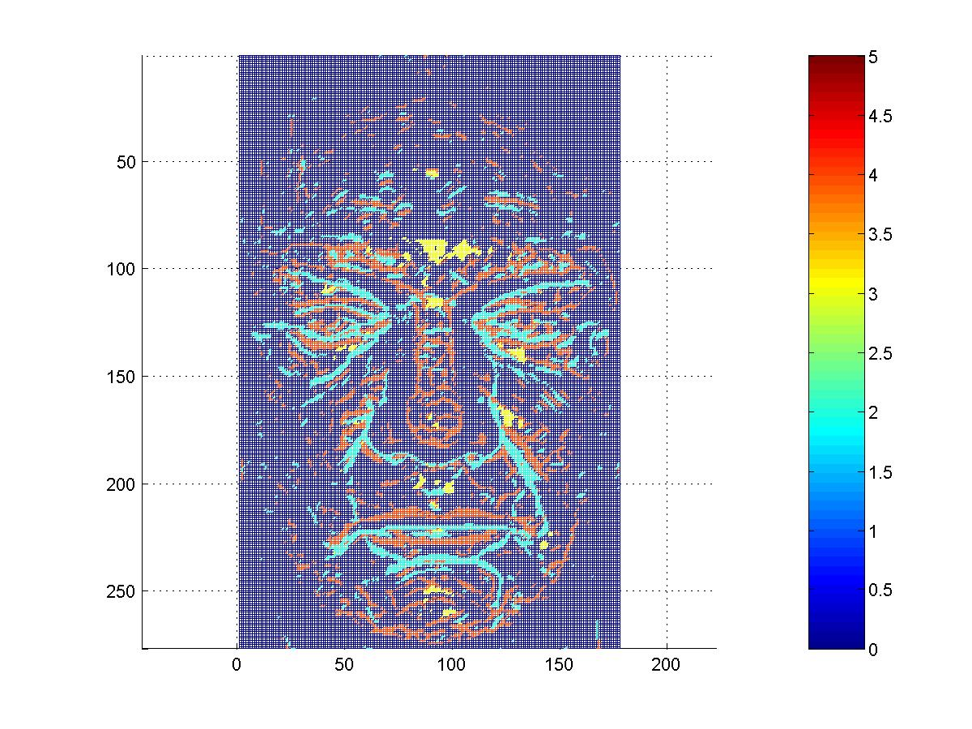
In MATLAB, TPS maps were constructed by the created m-file, ptclass.m. Ptclass.m takes the range image and the flag matrix, calls on principal.m to get the principal curve information, and returns a TPS map based on the classifications shown in table 1. Each point was numbered accordingly (and the accompanying map is show in figure 4):
Figure 4: TPS map of a face. Each color denotes a different feature type.

The points are classified by their numeric value:1 – pit, 2 – ravine, 3 – saddle, 4 – ridge, 5 – Peak, 0 - flat/wall. Only extrema where denoted, and all flat areas (plans, slopes, etc.) where marked as zero, but the m-file could be adjusted to include and classify different flat areas.

III.B Salient Points

Another technique to find features involves Gabor Wavelets to discover salient points. A salient point is defined to be either a prominent feature or a protrusion, and both are applicable.

III.B.1 Gabor Wavelets and Decomposition
The first step in salient point detection is to decompose the face by a Gabor wavelet transform[3]. A wavelet is a waveform that is bounded in both the frequency and time domain. A wavelet transform is a convolution of the wavelet with a given function, i.e. filtering the function with the wavelet. In fact, the wavelet transform and Fourier transform are very similar. In the discrete application at least, the FFT and discrete wavelet transform are both liner operators that have basis functions that are localized in the frequency domain.
But the main advantage of the wavelet transform over the Fourier transform is that because the Fourier transform is based on sine and cosine functions, which are not localized and stretch to infinity, windowing functions are all similar and resolution of filtered data is the same everywhere. The Wavelet transform is based around a prototype wavelet, called the “mother wavelet.” Additional basis functions are simply translations and rotations of the mother wavelet, called anything from “daughter wavelets” to “offspring wavelets.” Each of these wavelets can be adjusted so that one can capture a very detailed analysis then later a very broad, general analysis. In other words, it is more flexible than a Fourier transform and provides more information.
Manjunath, Shekhar, and Chellappa in their 1996 paper present a way to discover image features use the Gabor wavelet. Gabor functions are “Gaussians modulated by a complex sinusoid.” [3] An attractive property of the Gabor function and Fourier transform is that they “achieve the minimum possible joint resolution in space and frequency.” [BSm2,p1] As explained before, a Fourier transform is vague in the sense that resolutions are uniform and cannot be tuned for finer details. Manjunath, Shekhar and Chellappa therefore use the Gabor Wavelet family (mother and daughters) for feature extraction.
The basic Gabor wavelet takes the form [3]:
g _{λ}(x,y,Ø) = exp(-(λ ²x’²+y’²) + iπx’)
where:
x’ = xcosØ + ysinØ
y’ = -xsinØ + ycosØ
In the above, λ is the spatial aspect ratio and Ø is any orientation angle, 0 to π. In the calculations in [3], λ is set to 1. The corresponding offspring wavelets are scaled (alpha), orientated (Ø_{k}) versions of the basic wavelet. Allowing the orientation to be discretized into N intervals and the scale parameter to be taken exponentially by j, the family is then described by [3]:
g(a^{j}(x-x₀,y-y₀), Ø_{k}), a ∈ real, j = {0,-1,-2,…}
Where Ø_{k} = (kπ)/N. This gives a wavelet transform of:
Wj(x,y,Ø) = ∫ f(x₁,y₁)g*(a^{j} (x-x1,y-y₁),Ø) dx₁dy₁
By this, a range image, f(x,y), like that presented for TPS maps, can be transformed into the frequency domain that is responsive to a desired scaling and orientation. An example of a gabor wavelet and a face decomposed by the wavelet is showing in figure 5. In MATLAB, Gabor decomposition was executed with the created m-file, gabytf.m. GabyTF.m took a range image, a desired scaling factor and power, orientation angle, and the flag matrix of valid face points, calculated the Gabor wavelet from the given information, and returned the decomposed, complex image.
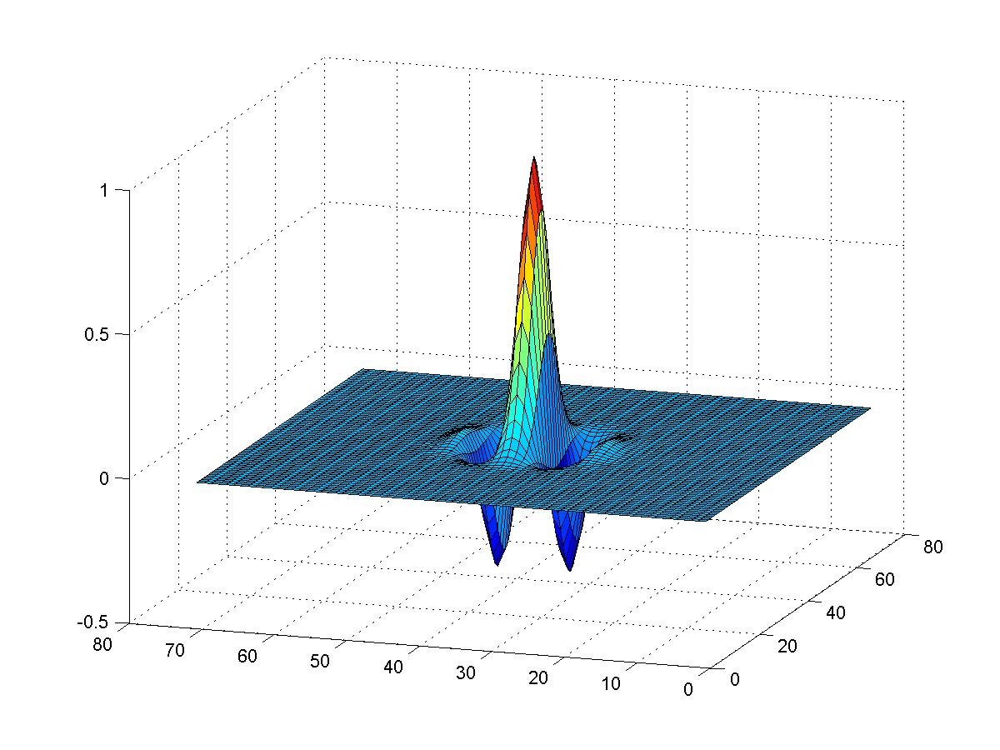
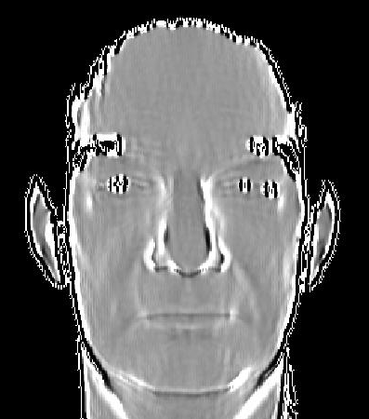

Figure 5: A Gabor wavelet(right) and a wavelet decomposed face (left)

III.B.2 Feature Detection and Salient Points
The transformed image under one exponent of the scaling factor can provide useful information about the edges of the face, but the features of interest are best discovered when the interaction of two different Gabor wavelet filters are examined. Manjunath, Shekhar, and Chellappa then introduce the feature detector equation [3]:

Q_{ij}(x,y,Ø) = K(W_{i}(x,y,Ø)- £*W_{j}(x,y,Ø) )

Where £ is a normalizing factor, £ = a^2(i-j) K(*) is a non-linear transform. In this experiment, the log sigmoid function was used (in MATLAB: logsig.m), which forces the output to be a positive number between 0 and 1:

logsig(n) = 1/(1 + exp(-n))

Q_{ij} of the entire face is known as the scale-interaction model. Applied to the entire face, the feature detection equation creates a new representation in the frequency domain. Salient points are then defined as the local maximums of the scale-interaction model. As explained in Manjunath et al., taking the difference of the (scaled) filtered outputs results in a model that is “responsive to start line segments, line endings, and in general changes in curvature.” (p.5)
Applied to the face range data, the feature detection equation often has local maximums at the corners of the eyes, mouth, the edge of the nose, and many wrinkles in the skin. All of these features are characteristically sharp changes in the face surface and, as explained before, are often denoted by maximums in the scale-interaction model.
In MATLAB, the feature detection response was calculated with the created m-file, featloc.m. Featloc.m called gabytf.m twice to get two decompositions then performed the equation for Q_{ij}, the feature detection equation. It returned both the complex Q_{ij} as well as a map, “salient”, where:

“salient” = abs(Q_{ij})

Salient points where determined by the peaks of “salient.” In figure 6 is an example of a salient map. The sharp, stalagmite-like peaks denote the location of salient points. Many pints can be found at the corners of a face (nose, mouth, etc.).
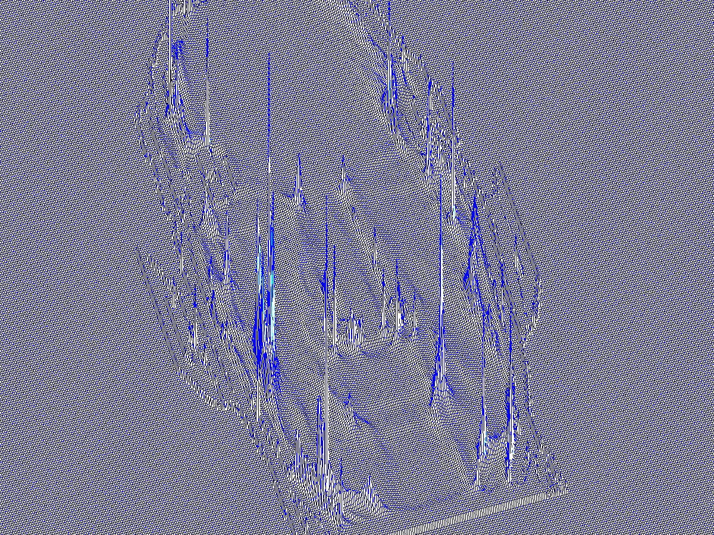
Figure 6: Map of “salient” ( = ||Qij|| ). Prominent peaks are salient points.

IV. Comparison Techniques.

IV.A. Correlation

According to Mathworld.com, correlation is “the degree to which two or more quantities are linearly associated.” It is a measure of how well values or changes in one set at a given position or time follow the values or changes in another set at the same time or position. In this project, correlation measured how similar two feature data sets were.
In MATLAB, correlation was executed using the corr2 command. The equation for the command is as follows:
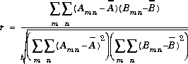
Where the barred A or B equals the mean. Correlation was one of the techniques used to compare TPS maps in [7], but as Meth points out, the number of points in each data set for each face was not uniform. Therefore a weighting was used to normalize the correlation measures of all the subjects. The equation for that weight is [7]:
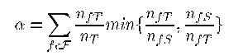
Where:
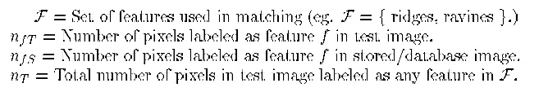

For this project, the weighting coefficient was dropped when measuring correlation of the salient points, but can later be adapted and used.

IV.B. Hausdorff Metric

The Hausdorff distance metric is one way to compare point clouds. Basically, it returns the maximum length of the closest points of two point clouds. Mathematically, the undirected Hausdorff distance between two point sets, A and B, is defined as[4]:
H(A,B) = max(h(A,B),h(B,A))
where h(A,B) is the directed Hausdorff distance[5]:
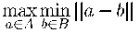
h(A,B) =
and ||*|| denotes the norm, or magnitude of the distance. In reality, the max and min operators are really the sup and inf operators, but for the purpose of feature comparison, the max and min operators perform fine. The process is simple and can be (computationally) speeded up by using stored distance transform maps of each set.
The potential problem with this simple, basic form of the Hausdorff metric is that any random noise in the data can alter the measure, perhaps significantly. Three-dimensional modeling of faces using technology like laser range finders or stereoscopic imaging, accurate, are still susceptible to noise. Also extraneous features, like hair falling over a face, can alter the geometry of the surface when it is captured for measure.
In their 2001 paper, Li and Chellappa use the Lp average version of the Hausdorff metric (proposed by Baddeley) [6]:
H^{p}(A,B) = [ 1/n(X) sum|(w(ro(x,A),c) – w(ro(x,B),c) )| ]^{1/p}
where A and B all lie within the set X, or simply X is the set of all image points of A and B, and w(*,c) is a cut off function w = min(*,c). Also in the above, n(X) is the number of points in X, and ro(x,A) is defined as:
(x,A) = inf{ρ (x,a)}
ρ(x,a) = ||x-a||
In the Lp average scheme, the importance of a single aberrant point is now weighted so that it no longer has as great an effect on the measure. The average also creates an “ ‘expected risk’ interpretation: given A, a set B which minimizes H^{p}(A,B) is one which maximizes the pixel wise likelihood of ρ (x,B) = ρ (x,A).” (p.898) Like before, computation speed can be reduced using stored distance maps.
In MATLAB, the Hausdorff metric was executed using a created m-file, haus.m, which executed the Hausdorff metric on the range image of each face. In the implementation, p = 6 and the cutoff(c) = 10 pixels.

V. Combination Schemes

Traditionally, the feature detection techniques and the comparison algorithms described above where used independently, used with other types of comparison algorithms, or used in conjunction with each other, but in a different way than described above.
The Hausdorff metric does not need any prior analysis of the face data. It can work directly on a point cloud, or in this case a face surface described by x,y and z coordinates. Gabor wavelets of a face have in the past been matched using elastic bunch graph matching, a process that utilizes a morph-able template or mask [8]. Meth and Chellappa in [2] mentions the use of correlation of TPS maps to identify an object, but in that scheme, correlation means a value of 1 for a feature match, a value of 0 for a miss-match, and the correlation is weighted based on the target face.
At the same time, it seems possible to combine techniques for feature detection and comparison methods. For each of the two feature extraction schemes, correlation measure and the Hausdorff metric were applied, and recognition rates were measured. A Hausdorff measure (using a distance map) was applied to the sparse point cloud of salient points, and a correlation between salient points was calculated directly. For the TPS map, a distance map was built by choosing a specific feature(s) to compare, like only ridge and ravine points, and isolating only those points. The Hausdorff metric was applied to the distance map of the “active” features. Correlation was measured like in the salient points case.
For this project, comparisons based solely on the Hausdorff metric and the above described TPS zero-or-one correlation, termed “point difference” in this project, were measured as a reference. Distance maps for the Hausdorff metric using bwdist on the edges detected by edge(range_image,’canny’,0.01).

VI. Results

In a facial recognition algorithm using a gallery, algorithms can order the faces in the gallery by who matches the target face the best, the first, highest position being the best candidate. Rank number denotes the lowest number in that the actual matching face is found. In table2, rank 5 signifies that the matching gallery face was found in the top five candidates chosen by the matching algorithm.
Table 2 below presents the results of this preliminary study:

Table 2: Combination Schemes and Recognition Rates
Feature Detection | Comparison | Rank 1 | Rank 5
Distance Map | Hausdorff | 40% | 55%
Salient Points | Hausdorff | 45% | 60%
Salient Points | Correlation | 15% | 35%
TPS | Hausdorff | 55% | 65%
TPS | Correlation | 55% | 65%
TPS | Point Difference | 75% | 80%

The above percentages are based on matching using a gallery of 24 persons, and 20 probe faces.

VII. Discussion

Overall, the TPS map in conjunction with point-difference correlation returned the highest recognition results in both rank 1 and rank 5. Perhaps more noticeable is that the TPS map provides consistently higher recognition rates than either Salient Point comparison schemes. This could be due to the fact that the TPS map provides data points of interest numbering on average in the two to three thousands. The number of salient points detected usually number less than one hundred. The TPS map is therefore more descriptive of the face than the salient points.
On the other hand, the sparseness of the salient point maps had the advantage of calculation speed and memory usage. While recognition rates were much lower than the TPS counterparts, comparison algorithms applied to salient points executed anywhere from twice to ten times faster than when applied to the denser TPS maps. While correlation of a sparse point cloud may not be advisable, if only for lack of information, the Hausdorff metric when applied to the salient point map, still achieved at least 60% rank 5 recognition.
Toward the confidence in the recognition rates reported, it should be noted that the rank 1 recognition rates of the two reference techniques, direct Hausdorff and TPS with point difference correlation, have considerably low recognition rates. For the TPS scheme, [7] reported recognition rates closer to 99%, 100% at best. For the Hausdorff metric, a paper by Acherman and Bunke reports recognition rates of 100%, and 72.2% minimum recognition rate when applied to a range image of a face.
While there may be some questions about implementation of the algorithms, specifically were these equations coded correctly in the MATLAB m-file, a great source of error was discovered upon reviewing the data: that of proper face registration. As mentioned before, the methods used to register the faces were very basic and were implicitly dependent on one assumption: the nose was the highest point of the range data.
Upon first build of the gallery data (salient point maps, TPS maps, distance maps, etc.) and first run of the recognition sequence for all of the target faces, rank 1 recognition rates achieved 25% at best. Adjusting certain constants in the algorithms (e.g. exponents of the scaling factor in the feature detector equation) did affect the performance rates, but not by a significant amount in either way. This hinted that possibly the algorithm was not entirely wrong, but something with that data might be. It turned out that it had to do mainly with the second assumption for the weak registration algorithm.
In almost all of the 24 gallery faces use, the nose was the highest point. However in some cases, locks of hair went flagged as valid, and the hair could protrude farther than the nose. Immediately this caused a problem in that a face that was hair-centered framed awkward parts of the face data, usually only the part surrounding the hair and not much if any of the actual face. Naturally this was a problem in the probe set of faces as well.
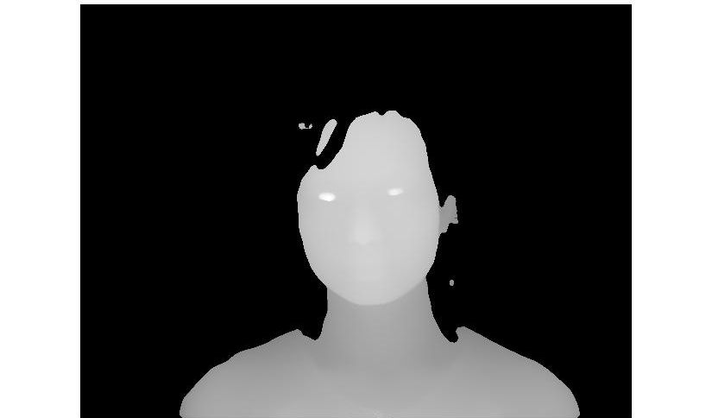

Because this problem was discovered so close to the due time of this report, rather than change the m-file, problematic persons were removed from the test. If it was a probe image, it was removed from the testing list; if it was a gallery image, it and the associated probe images were removed. Other odd behaviors occurred in pre-registration that were found out while checking the face data for “hair cropping.” These faces were dealt with in the same manner. Immediate tests after removing problem faces showed a dramatic increase, tripling the best rank 1 recognition rate. Further research with this project will extend into a better face detection and framing algorithm that can deal with the problem faces mentioned above.

Figure 7: Range Magnitude Image of a Face(top) and Badly Registered Range Image of the same face
Another concern that was more a restriction than a rate-affecting problem was that of memory. In all of the techniques used above, the data was treated as a range image. A face consisted of a height value at some x and y coordinate. In MATLAB, it is possible to create a three dimensional matrix, where a point on a surface is denoted as a ‘1’ at a given (x,y,z) coordinate. The problem with this is that models became 640 x 480 x (on average) 230 pixel models, which took up a great deal of memory. In fact, the program was unable to keep more than one 3D matrix of that size in it’s memory. One suggested solution was sub-matrix calculation, or to cut up the large matrix into smaller ones and work with each piece. An early m-file was created to write and store these sub-matrices, and another m-file was made to compare two faces. The problem was that the process of creating, storing, and then comparing two face models took a runtime of 10 minutes, which is not feasible for any real application. Further research in this project could better deal with inter-matrix calculation, speeding up the comparison process, or condensing the size of the matrix (cropping) or working with sparse matrices.

VIII. Conclusion

Applications of 2D face recognition techniques to 3D face models show early promising results. Though preliminary recognition rates are low by practical standards, observations about the above processes can lead to a refined system. Alleviating some of the early problems in this project showed great increases in recognition rates. Current results hint that continued research and better adaptation of recognition algorithms, especially in various combinations, could lead to a very feasible recognition system using 3D face models.

Works Citied

[1] Bower, Kevin; Chang; Flynn. "A Survey of 3d and Multi-Modal 3D+2D Face Recognition." University of Notre Dame, IN (2004)

[2] R. Meth and R. Chellappa, "Stability and Sensitivity of Topographic Features for SAR Target Characterization", Jl. Opt. Soc. America, A, Vol. 16, pp. 396-413, Feb. 1999.

[3] B. S. Manjunath, C. Shekhar and R. Chellappa, "A new approach to image feature detection with applications" Pattern Recognition, vol. 29, no. 4, pp. 627-640, Apr. 1996.

[4] C. Guerra, V. Pascucci. ‘3D Segment Matching Using the Hausdorff Distance.” Image Processing And Its Applications, 1999. Seventh International Conference on (Conf. Publ. No. 465). Vol. 1 pp. 18-22. Jul 1999

[5] Bernard Achermann, Horst Bunke. "Classifying Range Images of Human Faces with Hausdorff Distance." ICPR, vol. 02, no. 2, p. 2809, International 2000.

[6] B. Li, R. Chellappa, Q. Zheng and S. Der, "Model-Based Temporal Object Verification Using Video'', IEEE Trans. Image Processing, Vol. 10, pp. 897-908, June 2001.

[7] R. Meth and R. Chellappa, "Target Indexing in Synthetic Aperture Radar Imagery Using Topographic Features", Proc. Intl. Conf. on Acoustics, Speech and Signal Processing, Atlanta, GA, pp. 2152-2155, May 1996.

[8] L. Wiskott, J. Fellous, N Krüger, C. von der Malsburg. “Face Recognition by Elastic Bunch Graph Matching.” IEEE Transactions on Pattern Analysis and Machine Intelligence. Vol. 19 No. 7 pp. 775-779 July 1997.

Additional Material:

Ballard, Dana; Brown. Computer Vision. Ch. 9 pp264-306. Prentice Hall. Edgewood Cliffs, NJ. 1982.

Forsyth, David A.; Ponce, J. Computer Vision A Modern Approach. Prentice Hall. NJ 2003.

W. Zhao, R. Chellappa, J. Phillips, and A. Rosenfeld, “Face Recognitions: A Literature Survey,” ACM Computing Surveys, pp. 399-458, 2003.

