Using Spectral Subtraction to Enhance Speech and Increase Performance in Automatic Speech Recognition

Submitted By: Ayanah S. George
Advised By: Dr. Carol Espy-Wilson and Om Deshmukh
Speech Communication Lab, Institute of Systems Research (ISR) & Electrical & Computer Eng. (ECE) Department, University of Maryland College Park

Maryland Engineering Research Internship Teams
(MERIT) Program 2005

TABLE OF CONTENTS

I. INTRODUCTION 3

II. METHODS & MATERIALS 4

A. Segmenting the Data
B. Taking the Fourier Transform
C. Compute Noise Spectrum Magnitude
D. Frame Averaging
E. Half-Wave Rectification
F. Residual Noise Reduction
G. Attenuate Signal during Non-Speech Activity
H. Signal Reconstruction
I. Materials Used

III. RESULTS 7

VI. DISCUSSION 13

V. REFERENCES 13

ABSTRACT

Presence of noise in speech signals deteriorates the performance of automatic speech recognition systems. Spectral Subtraction (SS) is a method used to reduce the amount of noise acoustically added in the speech signals. SS is implemented by estimating the noise spectrum from regions that are estimated as "noise-only" and subtracting it from the rest of the noisy speech signal. It is assumed that the noise remains relatively constant prior to, and during speech activity. My goal is to implement the SS algorithm to provide speech enhancement, evaluate it, and compare its performance with the "modified phase opponency" technique developed in our lab.

I. INTRODUCTION

Many systems rely on Automatic Speech Recognition (ASR) to carry out their necessary tasks. Using speech as their input it is important to ensure that background noise will not degrade the systems performance or ultimately inhibit it altogether. Spectral Subtraction (SS) [1] is an algorithm designed to reduce the degrading effects of noise acoustically added in speech signals. With applications from speech and language development in young children to aiding individuals with hearing impairments ASR is becoming increasingly popular and the demand for efficient systems is more evident. While humans are the best examples of ASR, the term as we know it usually means the process in which a computer recognizes and/or identifies spoken words. Although any task that involves interfacing with a computer can potentially use ASR, the following applications are the most common right now: Dictation, Command and Control, Telephony, Wearables and Medical/Disabilities [2].

This paper focuses on the removal of “white noise” in speech signals, which essentially enhances speech and strengthens the performance of systems relying on ASR.
White noise is a type of noise that is produced by combining sounds of all different frequencies together [3]. Because it contains all frequencies white noise can drown or mask other sounds which may contain significant information needed for input into an ASR system. If a reasonable estimate of white noise contained in a given speech signal can be obtained and removed from a signal, then we should see an improvement in the quality of the speech and efficiency for most ASR systems.

Other methods used to reduce the amount of noise in speech signals include: Noise-canceling microphones, although essential for extremely high noise environments such as the helicopter cockpit, offer little or no noise reduction above 1 kHz [1]. Another and one of the most efficient techniques to improve robustness of speech recognition systems on additive noise consists in training the acoustic models with data corrupted by noise at different signal-to-noise ratios (SNR)[4]. However as it is stated this method requires training by individuals in different environments, which may or may not be available in all situations.

As our day to day lives become more complicated, we find ourselves involved in a multitude of projects most of which require our hands or some other sort of physical interaction. ASR provides a “hands free” way to complete a variety of duties by simply speaking. Used effectively ASR systems can optimize most tasks and complete them at a rate that is substantially faster. In addition these systems can enhance the way the hearing impaired communicate, improve security and have provide authentication for many applications. For these and many more reasons, there is an obvious requirement for adequate ASR systems and their integration into our everyday life.

II. METHODS & MATERIALS

As stated earlier if a reasonable estimate of white noise contained in a given speech signal can be obtained and removed from a signal, then we should see an improvement in the quality of the speech. The following algorithm, SS [1], will outline the process needed to successfully remove a substantial amount of “white noise” from a speech signal.

A. Segmenting the Data

The data from the signal are segmented and windowed, such that if the sequence is separated into half-overlapped data buffers, then the sum of these windowed sequences adds back up to the original sequence [1]. 10ms windows of data were used in this analysis.

B. Taking the Fourier Transform

Let s(k) and n(k) be represented by a windowed speech signal and noise signal respectively. The sum of the two is then denoted by x(k),

x(k) = s(k) + n(k). (1)

Taking the Fourier Transform [5] of both sides gives

(2)
where
(3)

C. Compute Noise Spectrum Magnitude

To obtain the estimate of the noise spectrum the magnitude of is replaced by its average value taken during the regions estimated as “noise-only”. For this analysis the first 50ms were used as the “noise-only”.
The phase of is replaced by the phase of.
Through manipulation and substitution of equation (2) we obtain the spectral subtraction estimator:

. (4)

The error that results from this estimator is given by (5)

D. Frame Averaging

In efforts to reduce this error local averaging is used because is simply the difference between and its mean. Therefore is replaced with.

Where = ith time-windowed transform of x(k)

By substitution in equation (4) we have

(6)

The spectral error is now approximately

=- (7)
where
.

Thus, the sample mean of will converge to as a longer average is taken [1].
It has also been noted that averaging over more than three half-overlapped frames, will weaken intelligibility.

E. Half-Wave Rectification

For frequencies where is less than, the estimator will become negative, therefore the output at these frequencies is set to zero. This is half-wave rectification. The advantage of half-wave rectification is that the noise floor is reduced by [1]. When the speech plus the noise is less than this leads to an incorrect removal of speech information and a possible decrease in intelligibility.

F. Residual Noise Reduction

While half-wave rectification zeros out the speech plus noise that is less than, speech plus noise above still remain. When there is no speech present in a given signal the difference between N and is called noise residual and will demonstrate itself as disorderly spaced narrow bands of magnitude spikes. Once the signal is transformed back into the time domain, these disorderly spaced narrow bands of magnitude spikes will sound like the sum of tone generators with random frequencies. This is a phenomenon known as the “musical noise effect”. Because the magnitude spikes fluctuate from frame to frame, we are able to reduce the audible effects of the noise residual by replacing the current values from each frame with the minimum values chosen from the adjacent frames.
The motivation behind this replacement scheme is threefold: first, if the amplitude of lies below the maximum noise residual, and it varies radically from analysis frame to frame, then there is a high probability that the spectrum at that frequency is due to noise; therefore, suppress it by taking the minimum value; second if lies below the maximum but has a nearly constant value, there is a high probability that the spectrum at that frequency is due to low energy speech; therefore, taking the minimum will retain the information; and third, if is greater than the maximum, there is speech present a that that frequency; therefore, removing the bias is sufficient [1].

Residual Noise Reduction is implemented as:
for
for (7)
where
and = maximum value of noise residual measured during non-speech activity.

G. Attenuate Signal during Non-Speech Activity

The amount of energy in compared to supplies an indication of the presence of speech activity contained inside a given analysis frame. Empirically, it was determined that the average (before versus after) power ratio was down at least 12dB [1]. This offered an estimate for detecting the absence of speech given by:
If T was less than -12dB for a particular frame, it was classified as having no speech and attenuated by a factor c, where. -30dB, was found to be a reasonable, but not optimum amount of attenuation [1].
The output of the spectral estimate including signal attenuation is given by:

H. Signal Reconstruction

After bias removal, half-wave rectification, noise residual reduction and signal attenuation, the inverse transform is taken for each window and overlap added to form the output speech sequence. The system block diagram is shown in Fig. 1.

I. Materials

This entire algorithm was implemented and tested with MATLAB v. 6.5 software.

Hanning Window
FFT
Compute Magnitude
Subtract Bias
Half-Wave Rectify
Reduce Residual Noise
Compute Speech Activity Detector
Attenuate Signal During
Non-Speech Activity
IFFT
x(k)

Fig. 1 System Block Diagram

III. RESULTS

Illustrations of the performance of spectral subtraction are presented in several instances. A time spectrum of an utterance at 0dB is analyzed extensively and several other utterances are also examined to show the improvement of a noisy speech signal. For each analysis a time spectrum of the noisy signal and the enhanced signal will be shown. It is assumed that the noise remains locally stationary and that its spectral magnitude prior to speech activity remains the same during speech activity.

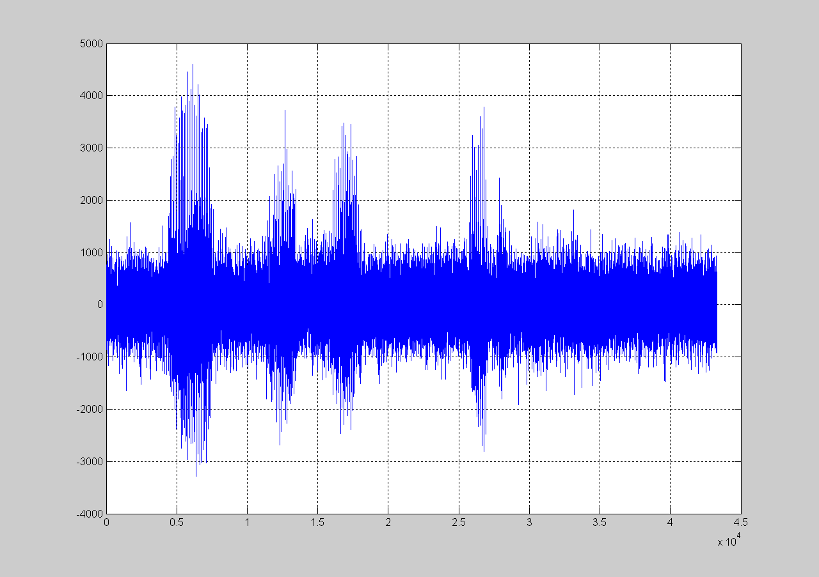

Fig. 2 Time waveform of speech utterance (1) “First add milk to the shredded cheese” at 0dB.

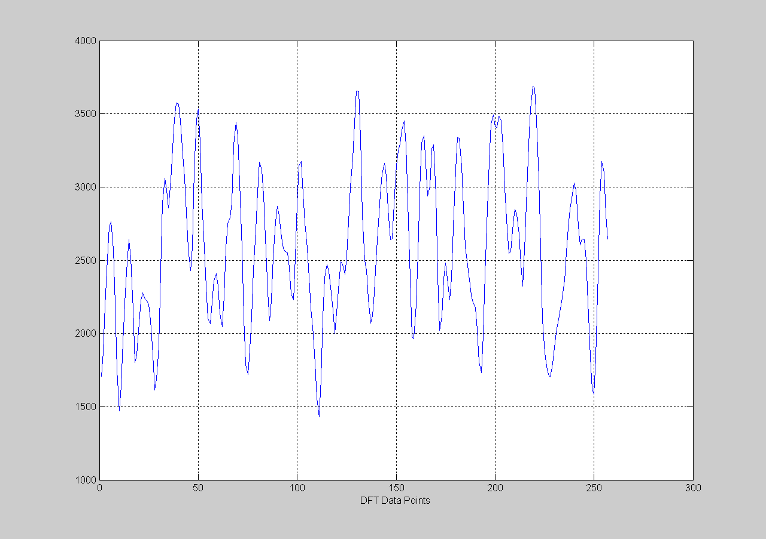

Fig. 3 Average noise magnitude of speech utterance (1).

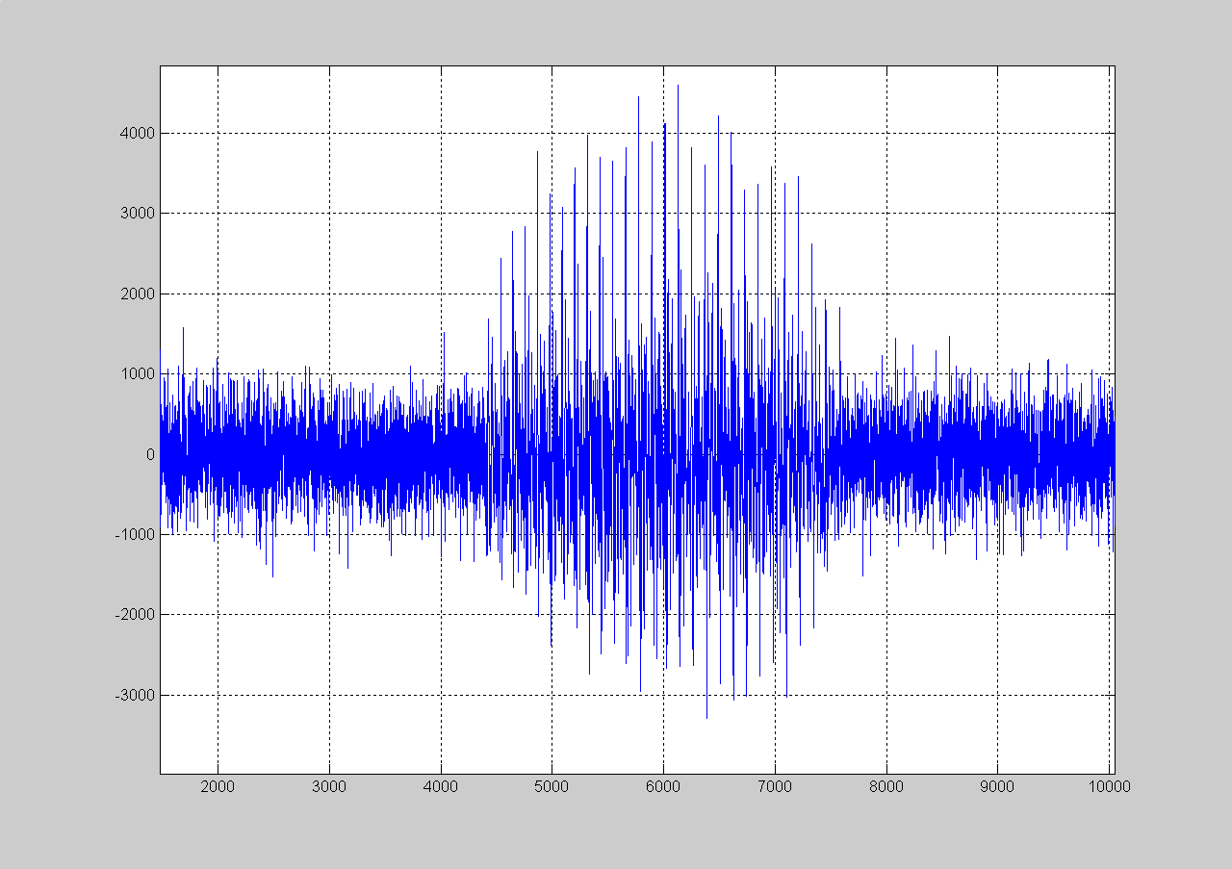

Fig. 4 Time waveform of speech utterance (1).

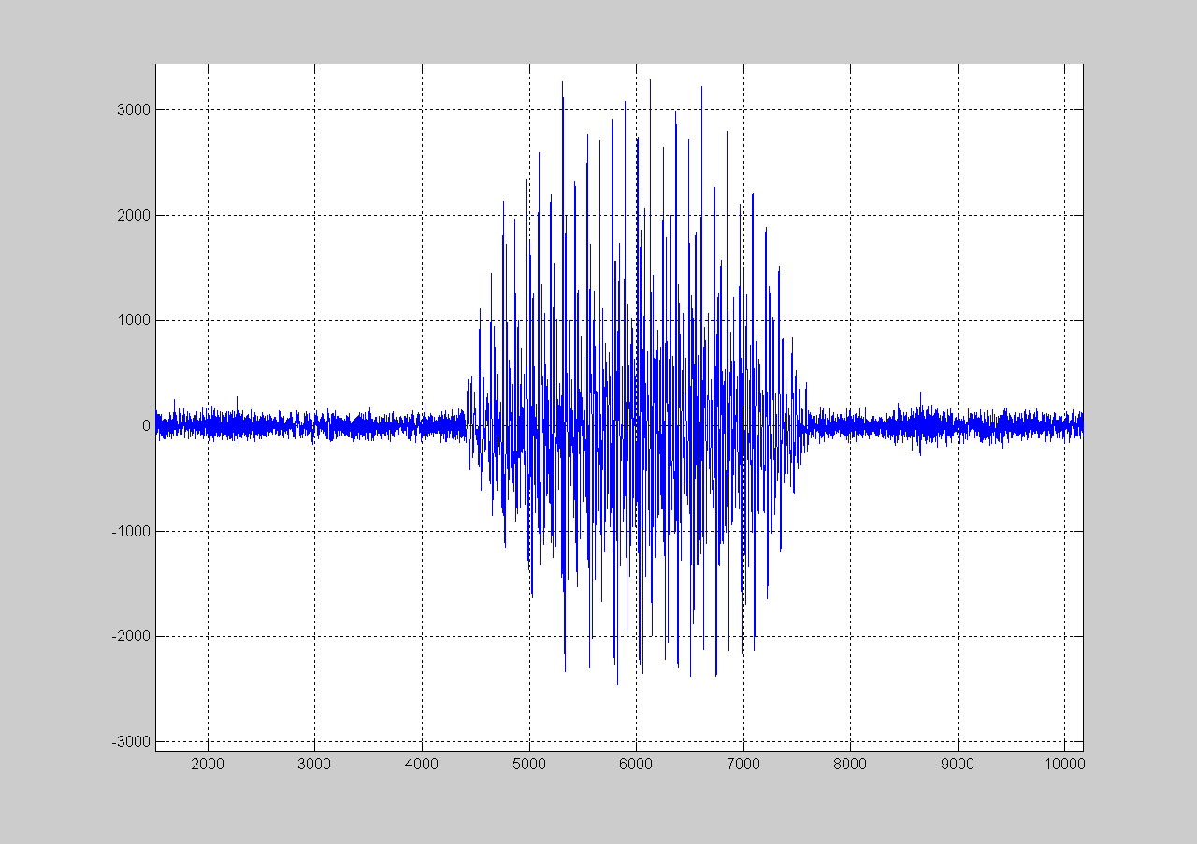

Fig. 5 Time waveform of speech utterance (1) using bias removal, half-wave rectification, three frame averaging, residual noise reduction, and signal attenuation.

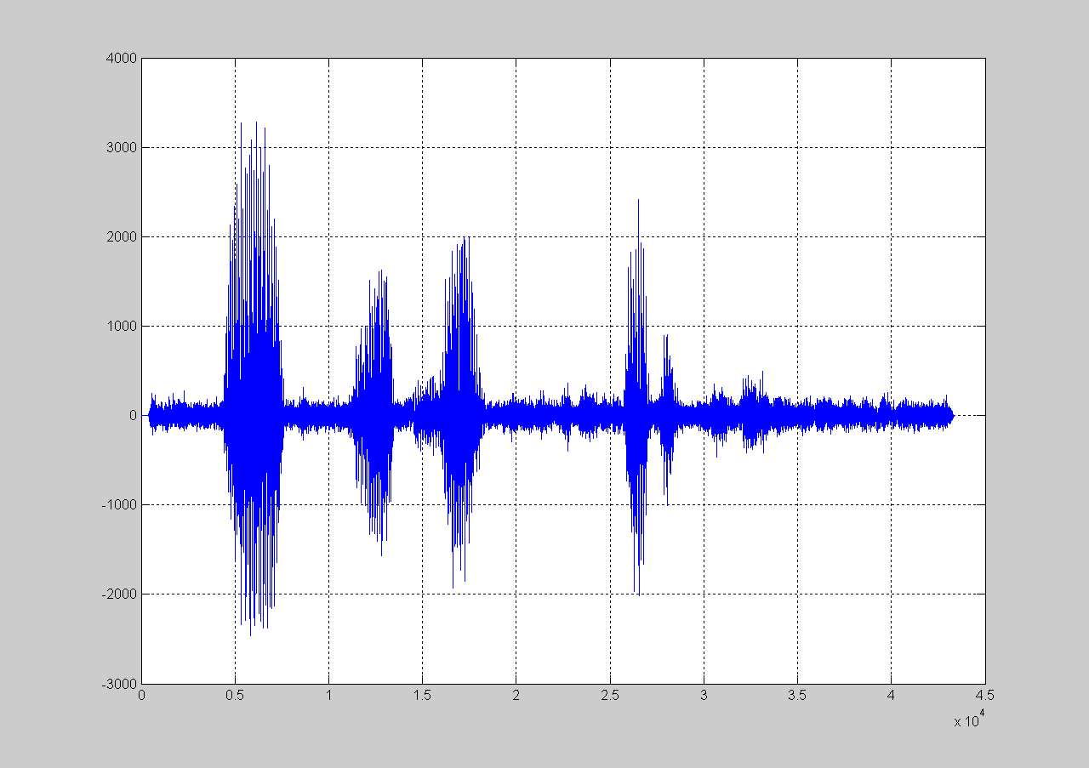

Fig. 6 Time waveform of speech utterance (1) after spectral subtraction.

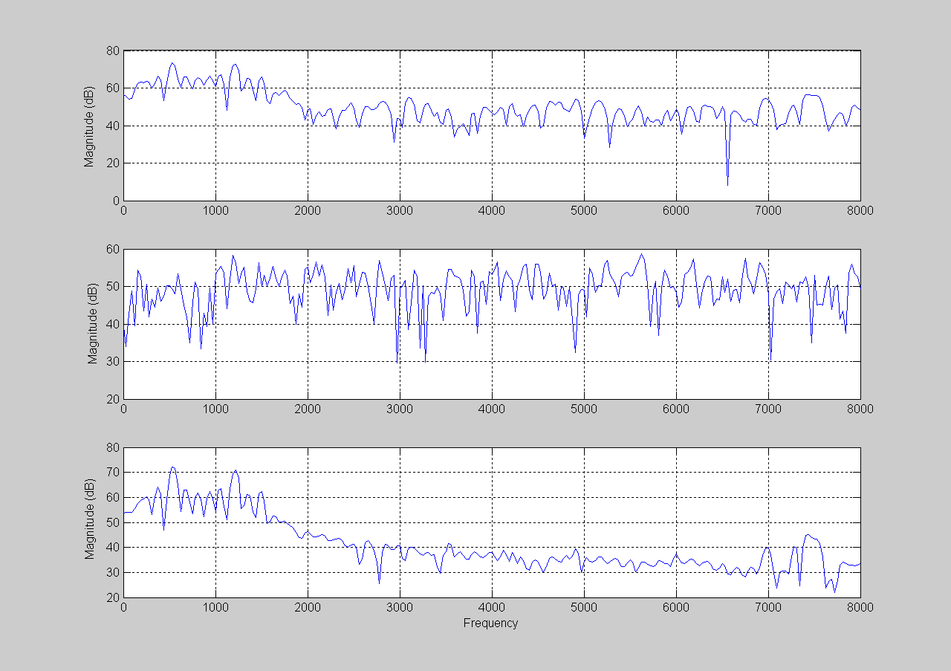
Fig. 7 Frequency spectrum of speech utterance (1). Top Panel: Spectrum of Noisy Signal
Middle Panel: Avg. Noise Magnitude , Bottom Panel: Spectrum of Enhanced Speech .

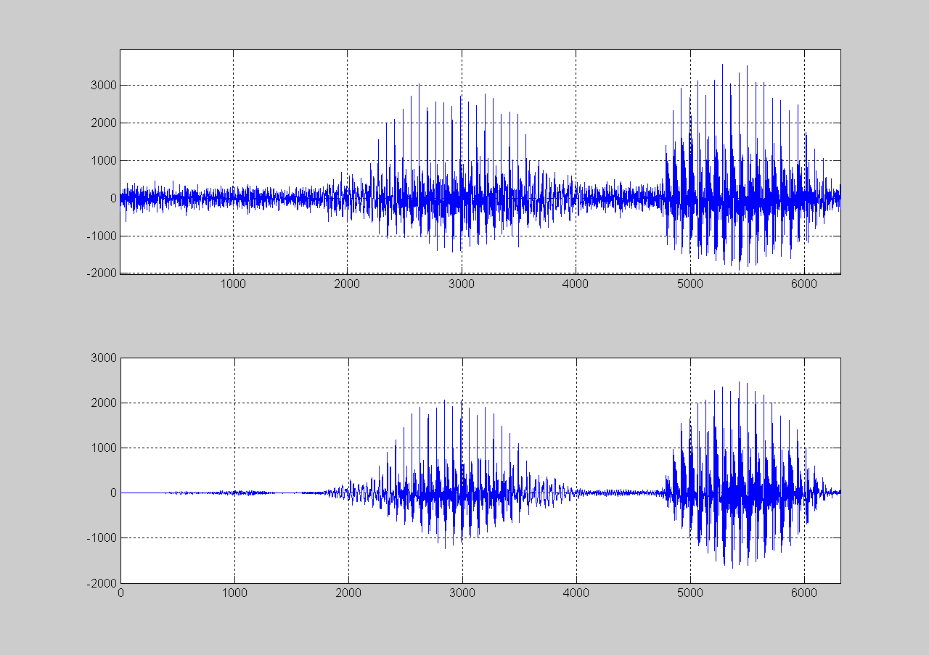

Fig. 8 Time waveform of speech utterance (2) at 5dB. Top Panel: Noisy Speech waveform
Bottom Panel: Enhanced Speech waveform

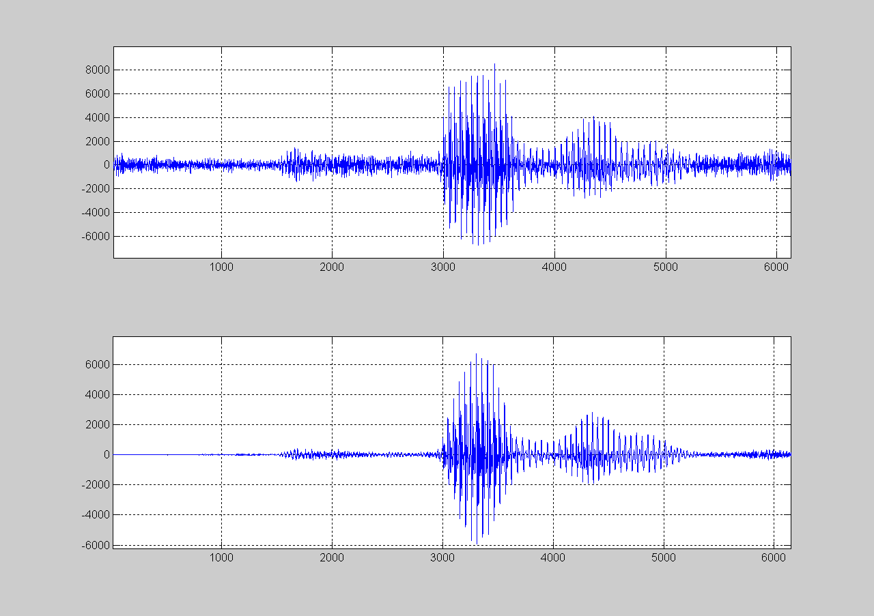

Fig. 9 Time waveform of speech utterance (3) at 10dB. Top Panel: Noisy Speech waveform
Bottom Panel: Enhanced Speech waveform
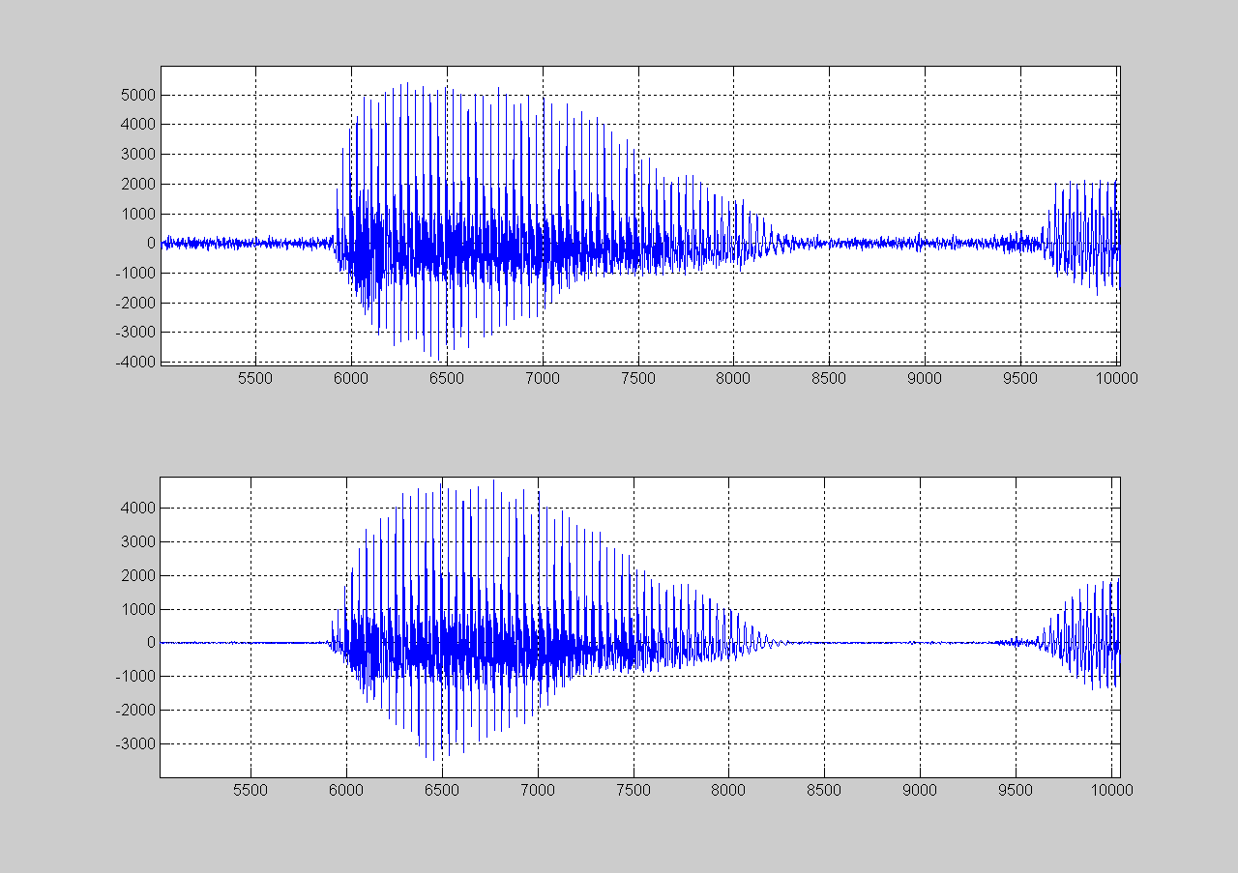

Fig. 10 Time waveform of speech utterance (4) at 15dB. Top Panel: Noisy Speech waveform
Bottom Panel: Enhanced Speech waveform

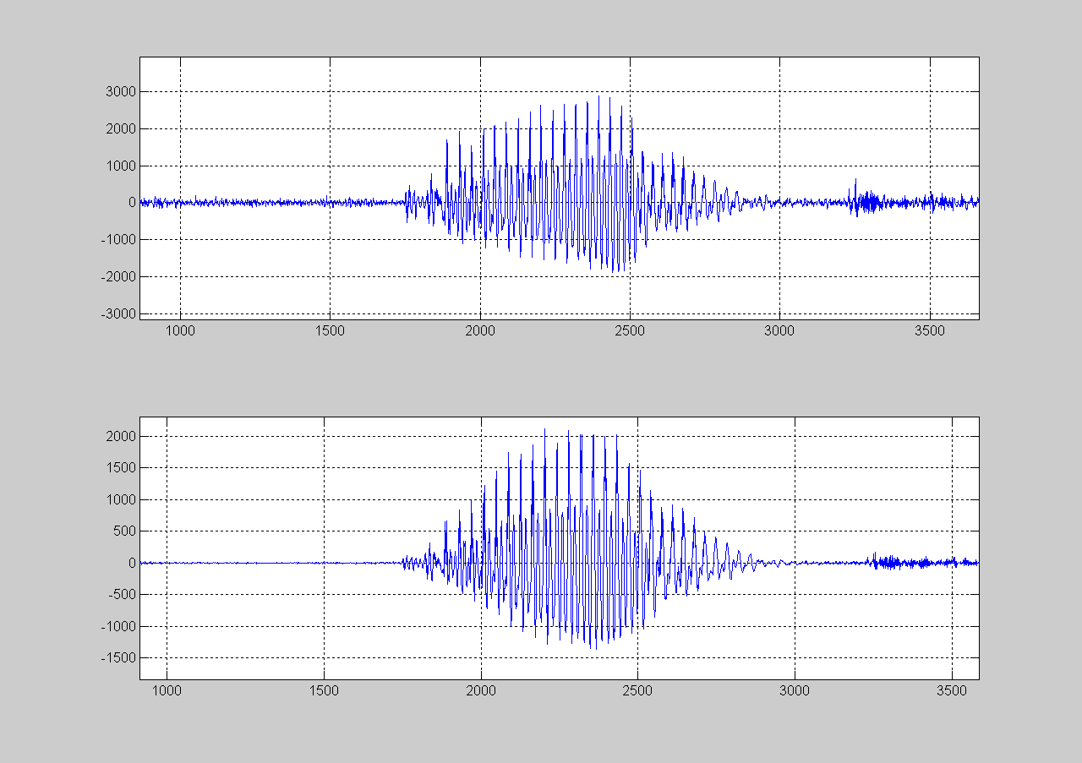

Fig. 11 Time waveform of speech utterance (5) at 20dB. Top Panel: Noisy Speech waveform
Bottom Panel: Enhanced Speech waveform

IV. DISCUSSION

Using SS, a noise removal algorithm has been successfully implemented and tested. Sufficient estimates of noise spectra were determined from initially noisy speech signals and effectively removed throughout the signal to produce an enhanced speech signal.
The enhanced speech signals were played back and demonstrated considerable improvement from the original signals. Some tribulations encountered during this implementation were discovered during the speech activity detector step, the algorithm only detected the first five and last two frames as having “no speech”, all other frames were found to contain speech information. This is an extremely low number of frames to be classified as “no speech” and was quite unexpected. In addition, due to randomly spaced narrow bands of noise residual, the final results exhibited the phenomenon known as the “musical noise effect”.
Work in progress includes comparing the performance of the SS algorithm with the “modified phase opponency technique” developed in this lab.
Overall the results display a considerable improvement in the quality of speech signals, which should increase the performance in ASR recognition systems.

V. REFRENCES

[1] Steven F. Boll, “Suppression of Acoustic Noise in Speech Using Spectral Subtraction”, Dept. of Computer Science, University of Utah Salt Lake City, Utah, April 1979
[2] Cook, Steven. “Speech Recognition HOWTO.” Home Page September 13, 2003. August 5, 2005 < http://www.faqs.org/docs/Linux-HOWTO/Speech-Recognition-HOWTO.html>
[3] “Howstuffworks.” What is White Noise? 1998 – 2005. August 5, 2005 <http://home.howstuffworks.com/question47.htm>
[4] St´ephane Dupont and Christophe Ris, “Multiband with Contaminated Training Data”, Facult´e Polytechnique de Mons, TCTS Lab, Mons, Belgium. International Computer Science Institute, Berkeley, California, USA
[5] Alan V. Oppenheim and Ronald W. Schafer, “Discrete-Time Signal Processing”. Prentice Hall, New Jersey 1989

