Ideas on how to help students write a research paper, submit it, and present it to a conference:
1. Require students to present
- Will help them think about how to describe their work; this will be critical to “telling their story” in the paper
- Will raise questions that will provide an opportunity (pre-review) to fill in holes
- Prepare tables and figures that will often belong in the final paper
Continuously write background
- Students should read, read, read at the beginning of the project
- Every paper should be meticulously recorded as a reference
- One to three paragraphs (generally depending on relevance) summarizing the paper – this become the background
- Provide them with review forms that are used to review papers for journals most relevant to their work
Pick an appropriate venue for submission
- Doesn’t need to be an undergraduate-specific conference
- Has an appropriate deadline (e.g. close to end of semester or end of summer)
- Good fit – especially important for undergraduates, who will likely face stiff competition – an excellent fit for a conference can boost the probability of being accepted
- Submission is an extended abstract – this allows incremental writing, can extend the range of an appropriate deadline, and generally provides fast turn-around on acceptance or rejection
Be very proactive
- Especially at the beginning students will be very tentative
- Must have quick turnaround on your end, as undergraduates will likely face resistance to writing – don’t give them any excuses to not write
- Provide a list of references on materials that give specifics on how to write a technical/research paper
Paper Accepted
- Incorporate reviewer feedback
- If paper was accepted as a poster or presentation, prepare additional materials.
- Plan travel—much better if students can attend
Paper Rejected
- Discuss with student another submission—student may no longer be in your lab
- Incorporate reviewer feedback
- Identify new venue based on same criteria as before
- Resubmit
Encourage a good balance of writing, reading and experimenting:
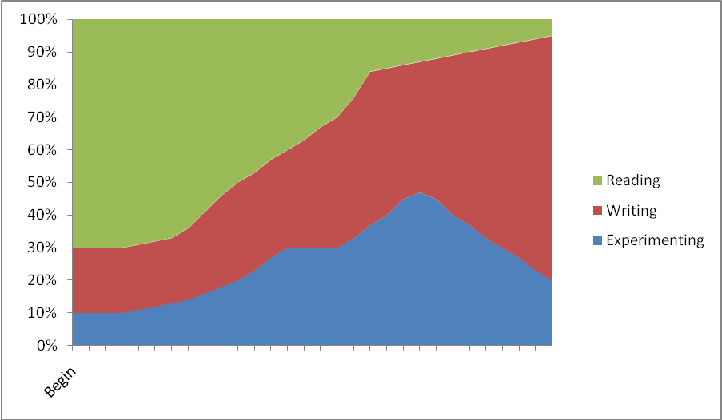
- While undergraduates will rarely be on a project as long as graduate students, with proper preparation and nurturing, they can generate significant results in 8 to 16 weeks
- Be prepared to learn—the first time is always a challenge, but it does get easier
- Publishing and presenting can be significant motivators; let them run

